|  |  |
| --- | --- |
| Assessment Title | Develop protocols |

## Competency Details

|  |  |
| --- | --- |
| Unit code/s and title/s | ICTICT443 Work Collaboratively in the ICT industry |
| Qualification code/s and title/s | ICT40120 - Certificate IV in Information Technology |
| Business unit/Work group | Business and Arts/IT Studies |

## Instructions

|  |  |
| --- | --- |
| Method/s of assessment | Questioning (Written)  Product (Create) |
| Overview of assessment | This assessment will require you to perform practical tasks and answer report questions. |
| Task/s to be assessed | This assessment will require you to complete the following tasks   * Task 1 – Develop Protocols * Task 2 – Develop and review Protocol * Task 3 – Meeting request |
| Time allowed | Refer to your schedule for submission dates |
| Location of assessment | Assessment can be completed anywhere with access to the resources required (see Resources Required section below) |
| Decision making rules | To receive a satisfactory outcome for this assessment you must complete all parts correctly.  Word counts are provided as guidance only. |
| Assessment conditions | This assessment must be undertaken where the conditions replicate noise levels and interruptions that people typically experience working in the ICT industry.  This is an unsupervised assessment and you may access any required resources.  This is not group work and must be completed as an individual. |
| Resources required | To complete this assessment, you will require the following:   * Access to Learn with Internet access * Learn resources * Word processing software such as Microsoft Word. * ACME Trading Services.ASDS folder * ACME Trading Services Report from Assessment 1 |
| Result notification and reassessment information | You will be provided feedback and the result for your assignment on TAFESA Learn. You will be and given the chance to resubmit with required corrections only once.  Refer to the TAFE SA assessment policy for more information <https://www.tafesa.edu.au/apply-enrol/before-starting/student-policies/assessment> |

**Scenario**

In this Assessment you will **Review and Developed Protocols** to work collaboratively in a virtual environment:

* to share knowledge collaboratively in a virtual environment according to work details and team objectives.
* to develop Cyber Security Protocols in accordance with organisational cyber security procedures.
* to develop Virtual ways of working Protocols

You will complete the ‘**Recommendations’** section and ‘**References’** section of the ‘ACME Trading Services Report’.

* Use the headings in the Report as a guide.

**You will be discussing your developed Protocols in your meeting with the other members of your Team in Assessment 3.**

**Task 1**

**Develop Sharing Knowledge Protocols**

You are to research and develop **two** protocols to share knowledge collaboratively in a virtual environment and update your ‘ACME Trading Services Report’ with these protocols.

**1.1 Review and Develop Meeting Protocol**

ACME Trading Services currently have a meeting Protocol.

The Meeting Protocol outlines the procedures to share knowledge effectively in a meeting.

Develop a protocol on ‘How to communicate effectively to share knowledge in a virtual environment’ collaboratively with team members’.

### Complete the ‘Recommendations - Share Knowledge Protocol 1’ section of the ‘ACME Trading Services Report’.

1. This protocol provides guidelines for the knowledge sharing process in a Virtual environment.

* Ensure that everyone has received prior notice of a meeting and what tool is being used
* Only use approved virtual platforms (teams and zoom)
* Check that everyone required has joined the meeting
* Ensure that everyone can speak/communicate whether by voice or chat
* Use a front facing camera showing your face at all times
* When not speaking mute your microphone.
* When away from computer, make it known, whether by writing a comment or using appropriate signage
* If you have something you would like to add to a presentation/conversation, use raise hand feature and speak when called upon
* Ask for and record feedback when a presentation is complete.
* Monitor chats within the virtual environment

**1.2**

**Sharing Knowledge Protocol**

* Develop a ‘Data Sharing Protocol’ that will include a procedure on the tools and technology that can be used to share knowledge in a virtual environment.

This protocol provides guidelines about sharing data within a collaborative environment

### Complete the ‘Recommendations - Share Knowledge Protocol 2’ section of the ‘ACME Trading Services Report’.

* For non-classified documents use the platform used (Microsoft teams/Zoom) to share documents
* Classified data must be shared with a password protection and encrypted when shared online.
* Only share data that is required
* Data within office areas can be shared physically through the use of a Storage device (ssd/HDD) or a physical copy such as a print out.
* Do not share data over unprotected internet such as in a café or a hotel.
* If specific data is required, request it from the appropriate person and have a plan to receive the data safely.
* Once you have received the data always have it on your person until review
* If digital always only connect to a device that is known to be connected to a secure internet connection and one that is approved by ACME
* If printing/scanning is required only use devices approved by ACME or devices that have an airgap to the internet.

**Task 2**

**2.1**

**Cyber Security Protocols**

ACME Trading Services currently has a Cyber Safety Protocol protecting the business while staff are at the office.

Staff will be provided with a work laptop for the move to a home office environment.

### Develop the following two Cyber Security Protocols to avoid any Cyber Security risks as staff make the move to a home office environment.

1. Hardware security Protocol: Storage of work devices

* Do not disclose the password for the device to anyone.
* Do not use a password that is in use elsewhere
* Do not use the device for non-work related activates
* Do not install software not cleared by IT
* If you will be away from view of the device for less than an hour, lock the device so that a password will be required to gain access, this should be automatic ,
* When away from the device for more than an hour, save all work and completely turn off the device and store in an area not visible and that is dry and cool.
* When you are finished with the device, completely turn off the device and store in an are not visible or easily accessible,

1. Internet usage Protocol: Appropriate use of Social media

* Do not post sensitive, private or confidential company information on social media
* Be respectful towards other co-workers
* Make clear that all views are your own and are not representative of ACME
* Respect the privacy of coworkers and customers
* If you want to post about co-workers or customers, get approval from ACME and or the co-worker

### Complete the ‘Recommendations - Cyber security protocol 1 and 2’ section of the ‘ACME Trading Services Report’.

* Use the headings in the Report as a guide.

**Task 3 – Meeting preparation**

You will be required to attend a meeting in Assessment 3 to discuss your developed Protocols.

The meeting **must** be held in Microsoft Teams!

* When you are ready to be placed into a Team, you may post to the ICTICT443 Forum post to find other team members.

<https://learn.tafesa.edu.au/mod/forum/view.php?f=67451>

* Teams **must** consist of a minimum of two students and a maximum of three students.
* If you are struggling to find other team members, contact your Lecturer who will work with you to organise your team!

Communicate with the other members of your team to:

1. organise a date and time when you are all available to conduct the meeting.
2. decide which member of your team will be acting as a Team Leader

**Note**: The Team Leader must send out a meeting request to the other members of the team to join the Microsoft Teams meeting.

**3.1**

**Screen capture** meeting request or meeting invitation here:

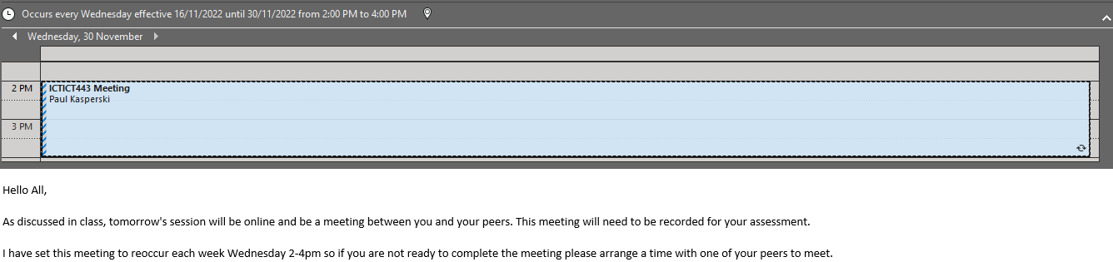

Assessment submission:

* Assessment 2 Develop Protocols document
* Acme Trading Services Report